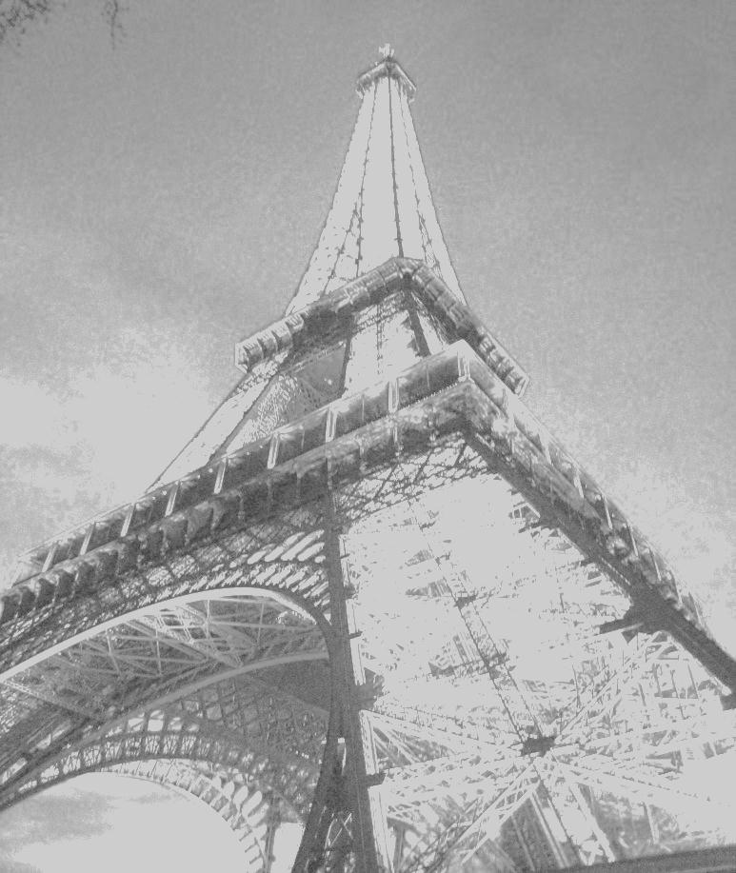
You are cordially invited to the division
Grand Opening

October 14
57 Rue Bergère
Paris, France

Addison Industries
European Division

